LAB NO# (07)
• LAB TITTLE:
“TO PRINT THE C++ PROGRAM USING WHILE LOOP TO SHOW A TABLE (MEAN TABLE OF A NUMBER)
• OBJECTIVE:
“ HOW TO PRINT THE C++ PROGRAM USING WHILE LOOP TO SHOW A TABLE (MEAN TABLE OF A NUMBER)
• TOOLS:
CODE BLOCKS SOFTWARE:
• PROCEDURE:
- First of all open the code block software in your Pc/Laptop.
- Then create a new project in C++ and save in some folder.
- Then start typing your program that you want to type.
- To print c++ program that using while loop to display the table a number
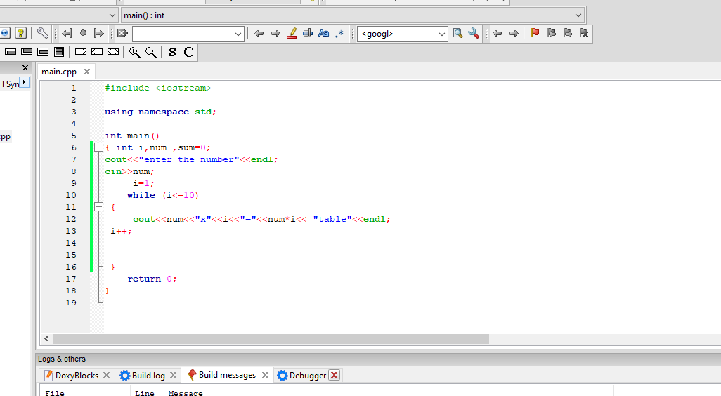

OBSERVATION
we are familiar with or observed that “how to print the c++ program using while loop to show a table (mean table of a number)

